Table of Contents
1 Introduction 1
2 Scope of change 1
3 List of impacted modules. 1
4 Design and Detailed technical updates. 1
4.1 Process model. 1
4.1.1 Use case Model 2
4.1.2 Sequence diagram 2
4.2 Proposed user Interface design 2
4.3 Database design changes 2
4.4 Refactoring related changes 2
4.5 Construction strategy and re-use 2
5 Details of Alternative Design Approach 2
6.Other Technical changes 2
6.1 Automation tasks / changes 2
6.2 CI / Build relates tasks / changes. 2
6.3 Non-functional related changes 2
7 Additional details. 2
7.1 Open Questions / clarifications / Assumptions 2
7.2 Additional notes to technical team 2
8 References 2

Table of figures

Figure 1.USE CASE DIAGRAM (author developed) 4

Tables of tables

Table 1. registration (Author developed) 4
Table 2. customer login (author developed) 5

1 Introduction

The hotel chain is a midsize hotel chain that operates two five-star hotels, two restaurants and one camping site and the company has a staff of 500 plus that work as permanent employees, temporary basis and short-term employees. The total capacity of the hotel chain is 1200 visitors at any given time. The main service the Hotel chain provides is the room for short and long stays. There are four types of rooms, superior, deluxe, guest and single. These can be identified as the main products of the company. Each room type focuses on the specific niche in the market.
At present the hotel uses a paper-based system to manage all the tasks of the chain. The managers take all strategic, tactical and operational decisions depending on the paper based manual system. The process by which organizational objectives are achieved by using resources is difficult and prone to errors due to the inherent limitations of the paper-based systems.
The decision-making process demands selecting the best alternative from the available solutions with a limited time period and in order to do that it is required to check different documents and get the view of different stakeholders. However, with the existing business structure it is impossible to make prompt decisions.

2 Scope of change

Change will not be entertained and whatever specifications mentioned in this document is final.

3 List of impacted modules.
All the functional modules will be created from scratch.

4 Design and Detailed technical updates.

4.1 Process model.

4.1.1 Use case Model

Figure 1.USE CASE DIAGRAM (author developed)

Brief Description | Customer Registration
Basic Flow | This use case describes how a client register in to the system  1. The client has to register himself into the system.  2. After the successful registration, client will get a success message.  3. The following information is required during registration.  · Name  · Address  · Email  · Mobile Number  · Bank Details
Alternate Flow | The system will validate the information provided. If any invalid data is found, the input form will be redirected with error message.
Validation | 1. Name is required and minimum 5 characters and max 30 characters.  2. Address can be alphanumeric.  3. City/State/Country/Province should be selected from a drop-down.  4. The Email should be valid.  5. Bank Account details should be valid.
Pre-Conditions | 1.Any Device (Laptop / Phone or any)  2.User should have network access with browser
Post-Conditions | Booking Success message should be visible

Table 1. registration (Author developed)

Brief Description | Customer Logging
Basic Flow | This use case describes how a user log-in in to the system  1. The customer has to logging himself into the system.  2. After the successful login, customer will be taken to the appropriate landing page.  3. The following information is required to login.  · email  · password
Alternate Flow | 1. The system will validate the credentials provided. If credentials are invalid, login form will be redirected again with error message.
Validation | 1. Valid Email  2. Valid password
Pre-Conditions | 1.Any Device (Laptop / Phone or any )  2.User should have network access with browser
Post-Conditions | Landing page has to be displayed.
Table 2. customer login (author developed)

4.1.2 Sequence diagram
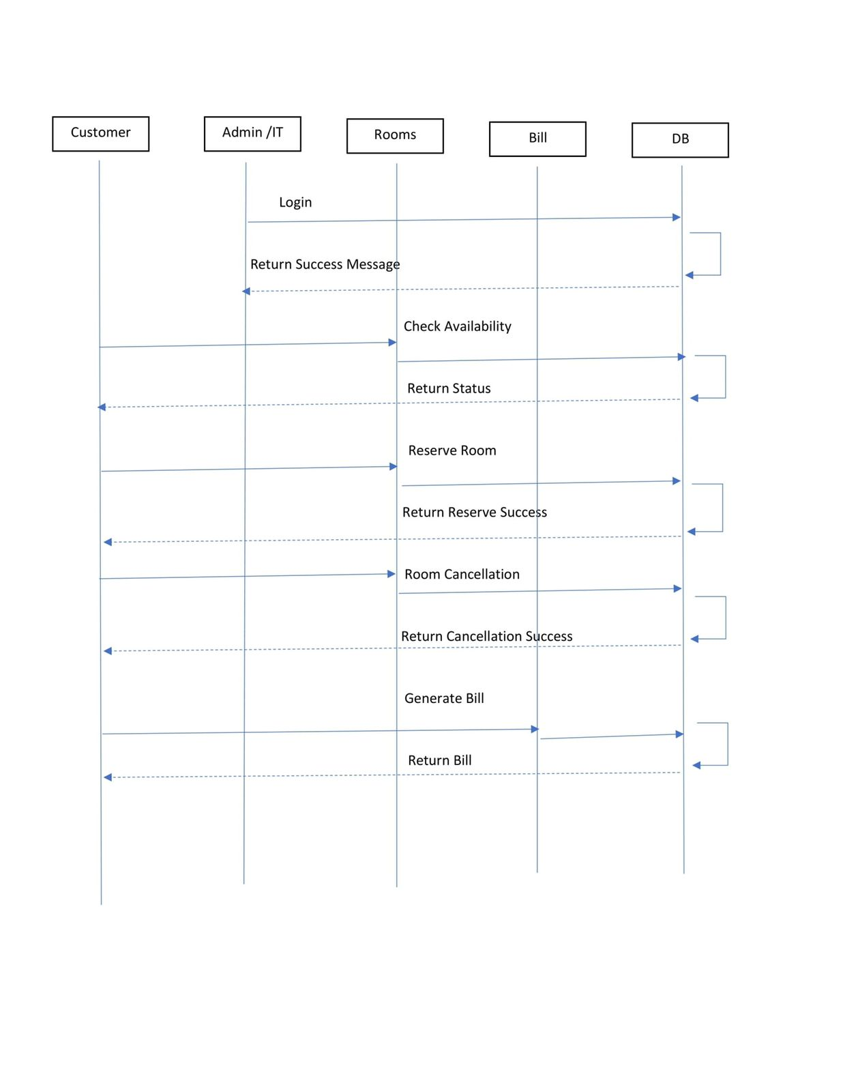

4.2 Proposed user Interface design

4.3 Database design changes

4.4 Refactoring related changes

4.5 Construction strategy and re-use

5 Details of Alternative Design Approach

6.Other Technical changes

6.1 Automation tasks / changes

6.2 CI / Build relates tasks / changes.

6.3 Non-functional related changes

7 Additional details.

7.1 Open Questions / clarifications / Assumptions

7.2 Additional notes to technical team

8 References

